**Analog systems: characterization of features in the time domain and frequency domains**

**Time Domain Analysis vs Frequency Domain Analysis**

The word analysis garners both provocations of thought and represents the epitome of illumination in terms of understanding. In essence, it is the process by which we discover or obtain a greater understanding of a person, place, or thing. Moreover, it is our analysis skills that usually keeps us safe, provided we actually use it.

I begin pedaling for dear life while I hear a few screams behind me followed by some intense growling from a Doberman. Luckily, no one was hurt, unless you count my stomach ache from all of the laughter. However, failure to use analysis tools in electronics is almost always detrimental. Take, for example, time domain analysis and frequency domain analysis; these are two such tools that can provide invaluable signal insight if properly used.

## **What is Time Domain Analysis?**

A time domain analysis is an analysis of physical signals, mathematical functions, or time series of economic or environmental data, in reference to time. Also, in the time domain, the signal or function's value is understood for all real numbers at various separate instances in the case of discrete-time or the case of continuous-time. Furthermore, an oscilloscope is a tool commonly used to see real-world signals in the time domain.

Moreover, a time-domain graph can show how a signal changes with time, whereas a frequency-domain graph will show how much of the signal lies within each given frequency band over a range of frequencies.

In general, when an analysis uses a unit of time, such as seconds or one of its multiples (minutes or hours) as a unit of measurement, then it is in the time domain. However, whenever an analysis concerns the units like Hertz, then it is in the frequency domain.

### ***How is Time Domain Analysis Different from Frequency Domain?***

Frequency domain is an analysis of signals or mathematical functions, in reference to frequency, instead of time. As stated earlier, a time-domain graph displays the changes in a signal over a span of time, and frequency domain displays how much of the signal exists within a given frequency band concerning a range of frequencies. Also, a frequency-domain representation can include information on the phase shift that must be applied to each sinusoid to be able to recombine the frequency components to recover the original time signal.

Furthermore, you can convert a designated signal or function between the frequency and time domains with a pair of operators called transforms. Moreover, a perfect example of a transform is the [Fourier transform](https://resources.orcad.com/orcad-blog/2019-rf-harmonic-balance-analysis-for-nonlinear-circuits). Which converts a time function into an integral of sine-waves of various frequencies or sum, each of which symbolizes a frequency component. The so-called spectrum of frequency components is the frequency-domain depiction of the signal. However, as the name implies, the inverse Fourier transform converts the frequency-domain function back to the time function.

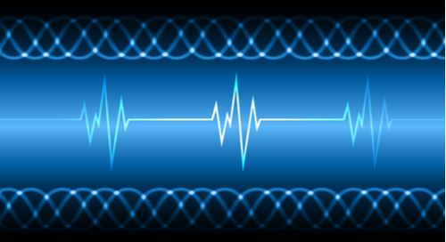

Managing antenna signals or audio transmission will change the type of analysis used.

## **Nuances Between Frequency and Time Domain**

Time domain analysis provides the transitory response of a system to be analyzed, and it permits a better understanding of the flow of both mechanical and electrical energies. In general, this includes wave propagation, the structural changes of a system, and electric potential generated by external excitations.

Whereas for the frequency domain, visualization tools such as a spectrum analyzer are commonly in use when visualizing electronic signals. Also, some specialized signal processing techniques make use of transforms, and this results in a joint time-frequency domain. Moreover, the instantaneous frequency is a critical link between the time domain and the frequency domain.

### ***Will Time Domain Analysis or Frequency Domain Analysis be Used More Often?***

Time domain analysis is particularly useful for circuit designs with antennas where a designer may encounter stray signals, reflections, or [ground bounce signals](https://resources.pcb.cadence.com/blog/what-is-ground-bounce). Time domain signal processing enables an engineer to separate extraneous signals in time from the desired signal, thereby identifying the contaminated signals.

In general, using a frequency domain will simplify analysis mathematically for the system running it. Many prominent SPICE tools will primarily function through the frequency-domain for this relevance, efficiency, and accuracy for their analytical functions.

Also, mathematical systems are an essential class of systems that have various practical applicational uses. Furthermore, for a mathematical system regulated by linear differential equations, it translates the depiction of a system from that of a time domain to a frequency domain. Thereby changing the differential equation to an algebraic equation, which is considerably less difficult to solve.

Seeing a system from the viewpoint of frequency will often provide an innate understanding of the measured quality that encompasses the behavior of the system. The scientific community now offers various terminology to describe such characteristic physical system behavior in reference to time-varying inputs. This includes terms like frequency response, bandwidth, phase shift, gain, and resonant frequencies, to name a few.

One of the most familiar and universal examples of frequency content in signals is perhaps [audio signals](https://resources.pcb.cadence.com/blog/2019-audio-amplifier-class-comparisons-and-how-to-simulate-them), such as music. In this case, the frequency-domain analysis gives a better understanding than time domain analysis because music is tacitly based on the breaking down of intricate sounds into their separate component frequencies.

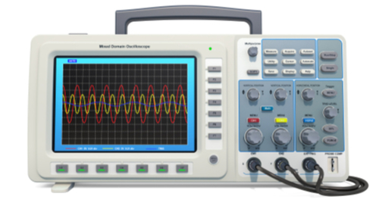

An oscilloscope is an invaluable tool for detecting signals.

When considering a sinusoid as an audio signal, we must also consider the changes in air pressure on our ears as a function of time. In summary, from the theory of operation of musical instruments to the musical notation in use to record and discuss music itself requires the separation of the component frequencies to gain an understanding of the audio in question.

Time domain analysis and frequency domain analysis are invaluable analysis tools. The use of either methodology depends on your individual design needs. However, in many cases, it is the use of both analysis techniques that yields the most useful insight into your design requirement needs.

# What is Analog Filter? – Different Types of Analog Filters

A filter can be defined with reference to various fields such as chemistry, optics, engineering, turbulence modelling, engineering, computing, philosophy, and signal processing. Let us consider signal processing filters, filter can be defined as a device used for removing unnecessary part or parts of the signal. This removing of unnecessary parts of the signal is called as filtering process. These signal processing filters are classified into various types such as [electronic filters](https://www.elprocus.com/fir-filter-for-digital-signal-processing/), digital filters, and analog filters

## **Analog Filters**

Analog filter is typically used in electronics and is considered as a basic building block of signal processing. These analog filters are used to separate audio signals before applying to loudspeakers. To separate and to combine several telephone conversations onto a single channel can be done using analog filters. To select a particular radio station from the radio receiver by rejecting all other channels can be done using analog filters.

The continuously varying signals (analog signals) can be operated using passive linear electronic analog filters which are composed of passive elements such as resistors, capacitors, and inductors. These analogue filters are frequently used for allowing particular frequency components by rejecting other from analog or continuous time signals.

### ***Types of Analog Filters***

The linear analog filters can be listed as network synthesis filters, image impedance filters, and simple filters. The network synthesis filters are again classified as a Butterworth filter, Chebyshev filter, Elliptic filter or Cauer filter, Bessel filter, Gaussian filter, Optimum ‘L’ filter (Legendre), and Linkwithz-Riley filter. The image impedance filters are further classified as a Constant k filter, m-derived filter, general image filters, Zobel network, lattice filter, bridged T delay equalizer, composite image filter, and mm’-type filter. The RC filter, RL filter, LC filter, and RLC filter are called as simple filters.

### ***Analog Filter Design***

The analog filter design includes analog filter transfer functions, poles and zeros of analog filters, frequency response of analog filters, output response, and different types of analog filters. The analog filter design filter methods are classified as Butterworth, Chebyshev, and Elliptic filter models based transfer function with order ‘n’.

#### **Butterworth Filter**

The [Butterworth or maximally flat magnitude filter](https://www.elprocus.com/butterworth-filter-formula-and-calculations/) has a flat (mathematically as much as possible) frequency response. The analog low pass filter’s (Butterworth) ‘brick wall’, which can be defined as standard approximations for various filter orders are shown in the below figure (including ideal frequency response).

If we increase the order of the Butterworth filter, then the Butterworth filter design cascaded stages also gets increased. Thus, as shown in the above figure the filter and brick wall response gets closer. Generally, the linear analog filters are realized using various topologies, the Butterworth filter can be realized using Cauer topology or Sallen-key topology.

#### **Chebyshev Filter**

The Chebysev filters are named after Pafnufy Chebyshev who derived the mathematical calculations of [Chebyshev filters](https://www.elprocus.com/types-of-chebyshev-filters/" \t "_blank). The error between the characteristic of idealized filter and actual filter can be reduced using the property of Chebyshev filter.

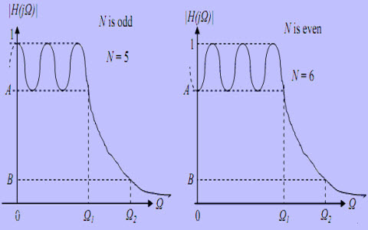

*Chebyshev Filter*

These Chebyshev filters are further classified as type1 and type2 Chebyshev filters. The type1 filters are basic type and the gain or amplitude response is an angular frequency function of the nth order of analog low pass filter (LPF-if we consider analog filters). The type2 Chebyshev filter is an uncommon type and is an inverse filter.

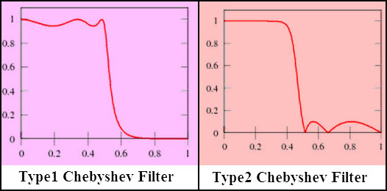

*Types of Chebyshev Filter*

#### **Simple Analog Filters**

**RC-Filter**

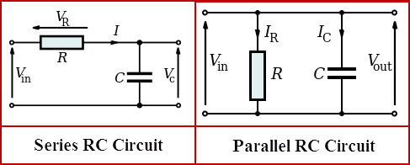

RC Filter Circuit

The simple resistor-capacitor electric circuits driven by current or voltage source acts as analog filters. These RC filter circuits are used for filtering a signal such that they block specific frequencies and allows other frequencies to pass. The RC filter circuit can be connected as series [RC circuit](https://www.elprocus.com/rc-snubber-circuits/) or parallel RC circuit as shown in the above figure.

**LC-Filter**

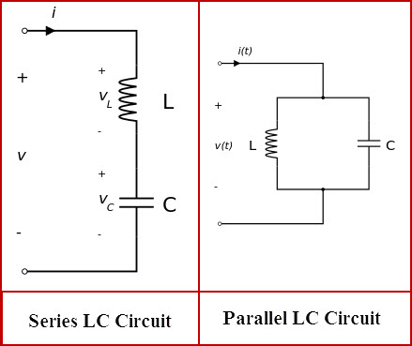

*LC Filter Circuit*

The simple inductor-capacitor electric circuit acts as an LC filter which is also termed as tuned circuit or resonant circuit or tank circuit. This LC circuit also behaves like an electrical resonator. The LC circuits are used to generate signals or to pick up signals at a specific frequency. The LC filter can be connected as series LC circuit or parallel LC circuit as shown in the above figure.

**RL-Filter**

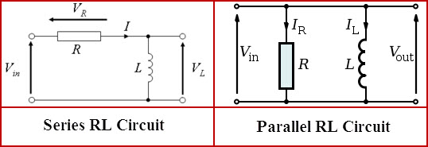

*RL Filter Circuit*

The simple resistor-inductor electric circuit acts as an RL filter circuit which is driven using current or voltage source and is made of the resistor and inductor. The RL filter can be connected as series RL circuit or parallel RL circuit as shown in the above figure.

**RLC-Filter**

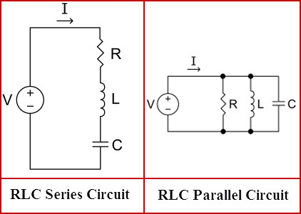

*RLC Filter Circuit*

The simple resistor-inductor-capacitor electric circuit acts as an RLC filter circuit, the resistor, capacitor, and inductor can be connected in series or parallel to form series RLC-filter or parallel RLC-filter. This RLC filter circuit forms as harmonic oscillator for current and resonates like an LC circuit. But, here the oscillations can be decayed by introducing a resistor and this effect is termed as damping.

Do you want to know in detail about practical analog and digital filter design? If you are interested in designing [electronics projects](https://www.elprocus.com/latest-electronics-projects-ideas/) then, share your views, comments, queries, and suggestions in the comments section below.